ASSIGNMENT-5.3 NAME: v.praneeth

ROLL.NO: 2303A52146

BATCH: 41

### Task 1: Privacy and Data Security in AI-Generated Code

Objective:

To analyze AI-generated login code for security flaws and revise it to follow responsible and secure coding practices.

### Prompt Used for AI Tool:

Generate a simple Python login system for username and password authentication. Generated code:

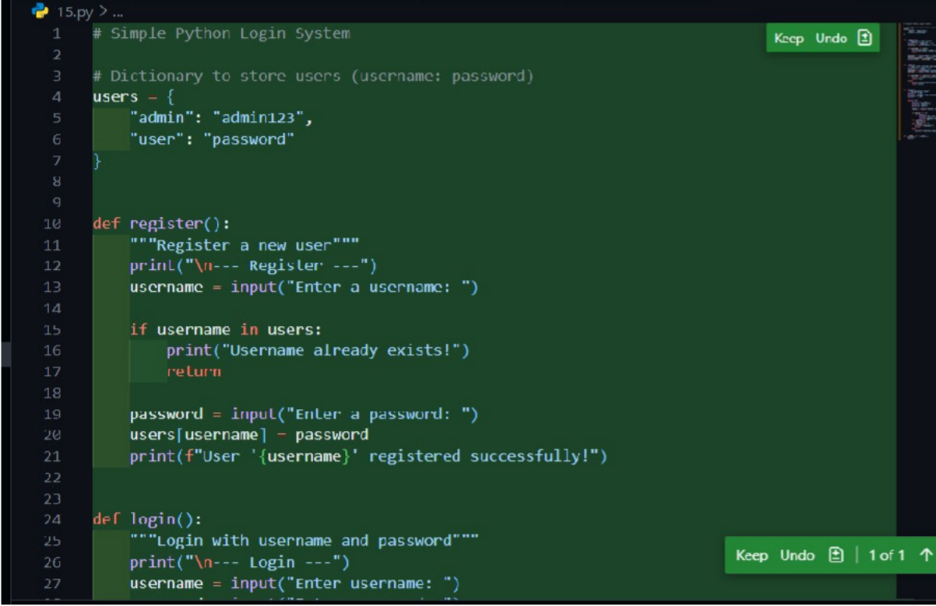

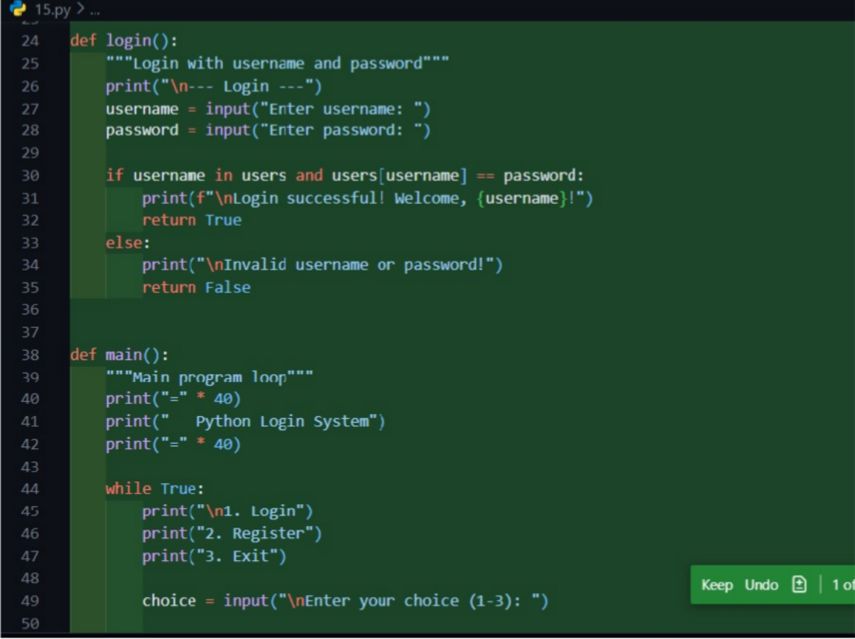

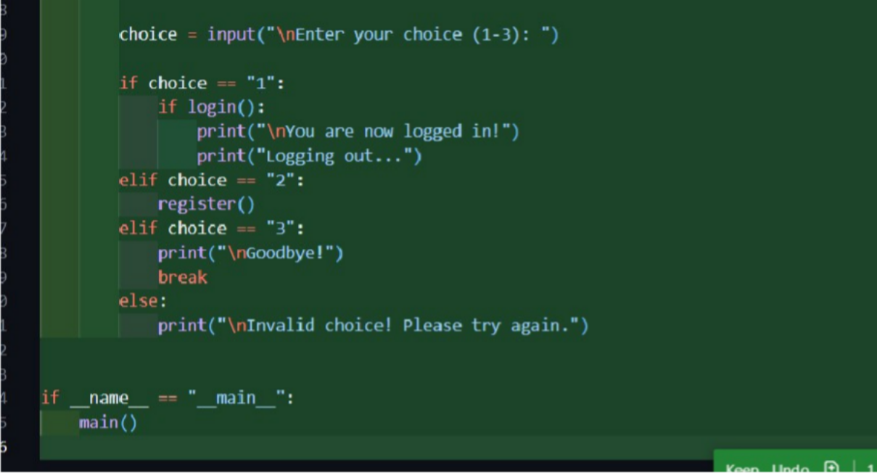

Output:

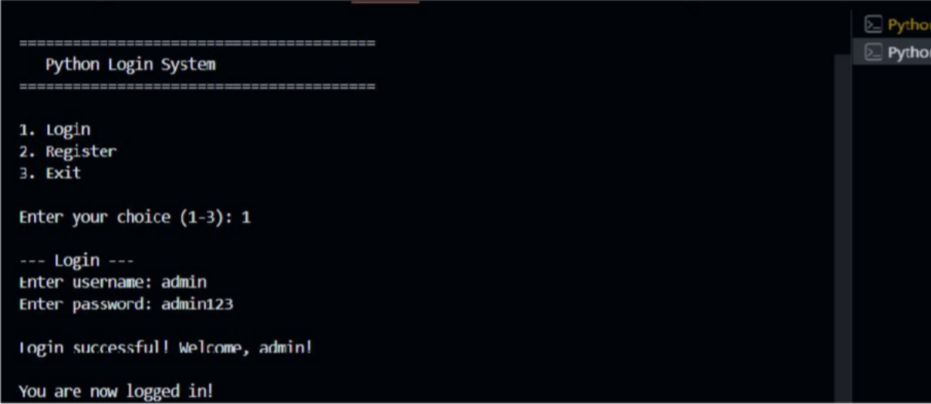

For wrong credentials

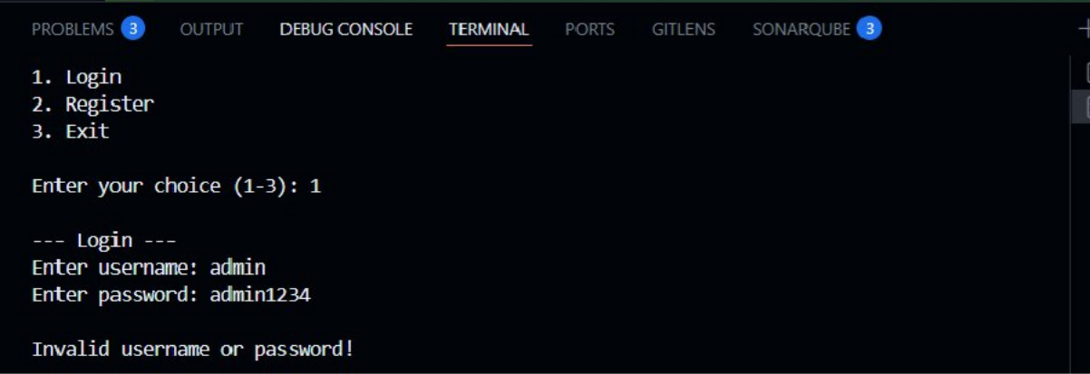

### Security Issues Identified

1. Hardcoded Credentials
   * Username and password are directly written in the source code.
   * Anyone with access to the code can see the credentials.
2. Plain-Text Password Comparison
   * Password is stored and compared in plain text.
   * Vulnerable to password leakage and attacks.
3. No Input Validation
   * No checks for empty or invalid input.
4. No Password Hashing
   * Violates standard authentication security practices. Improved code with security

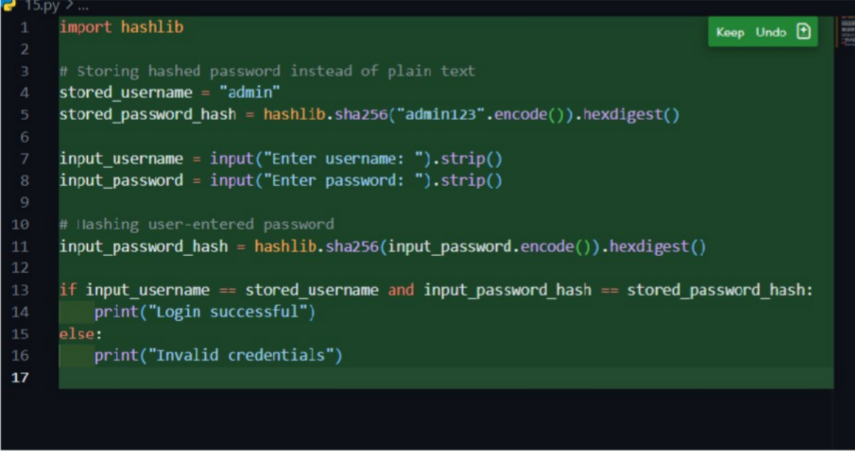

Output for correct credentials



For wrong credentials



Justification for improved code

### Password Hashing

* + SHA-256 hashing is used to prevent storing passwords in plain text.
  + Even if data is exposed, actual passwords are protected.

### Reduced Risk of Credential Theft

* + Password comparison is done using hashes, not raw strings.

### Basic Input Sanitization

* + .strip() removes accidental spaces and avoids simple input errors.

### Ethical Responsibility

* + Developers must not blindly trust AI-generated code.
  + Human review is essential to ensure privacy, security, and responsible AI usage.

# Task 2: Bias Detection in AI-Generated Decision Systems

## Objective

To evaluate AI-generated decision logic for bias and identify unfair treatment based on irrelevant personal attributes such as name or gender**.**

Prompt Used for AI Tool

Create a Python loan approval system based on applicant details like income, credit score, gender, and name.

Code generated

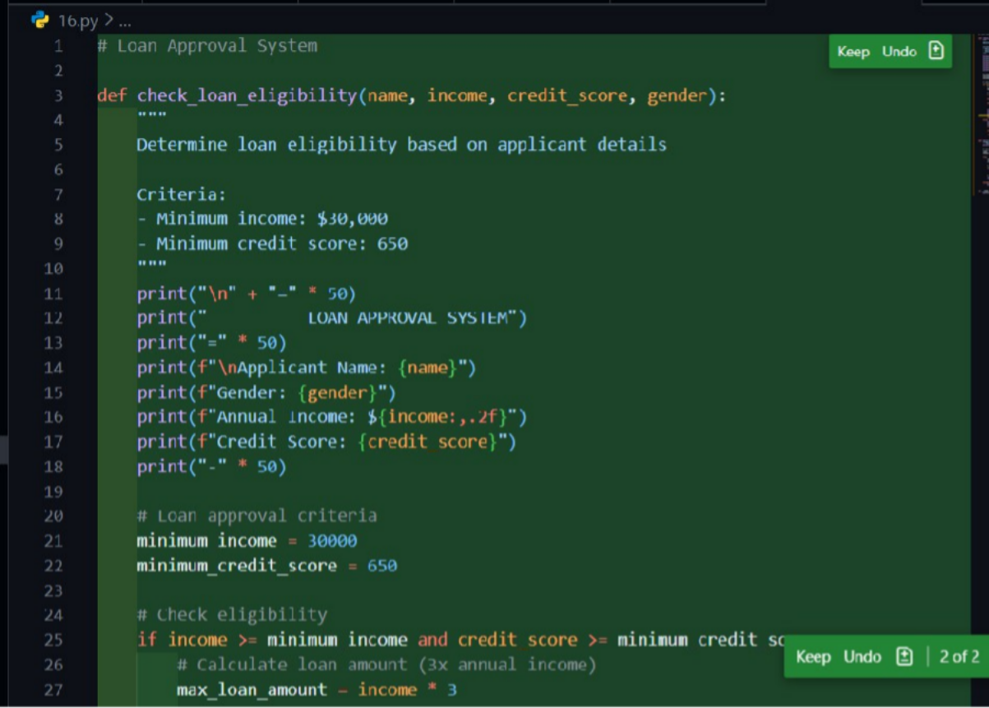

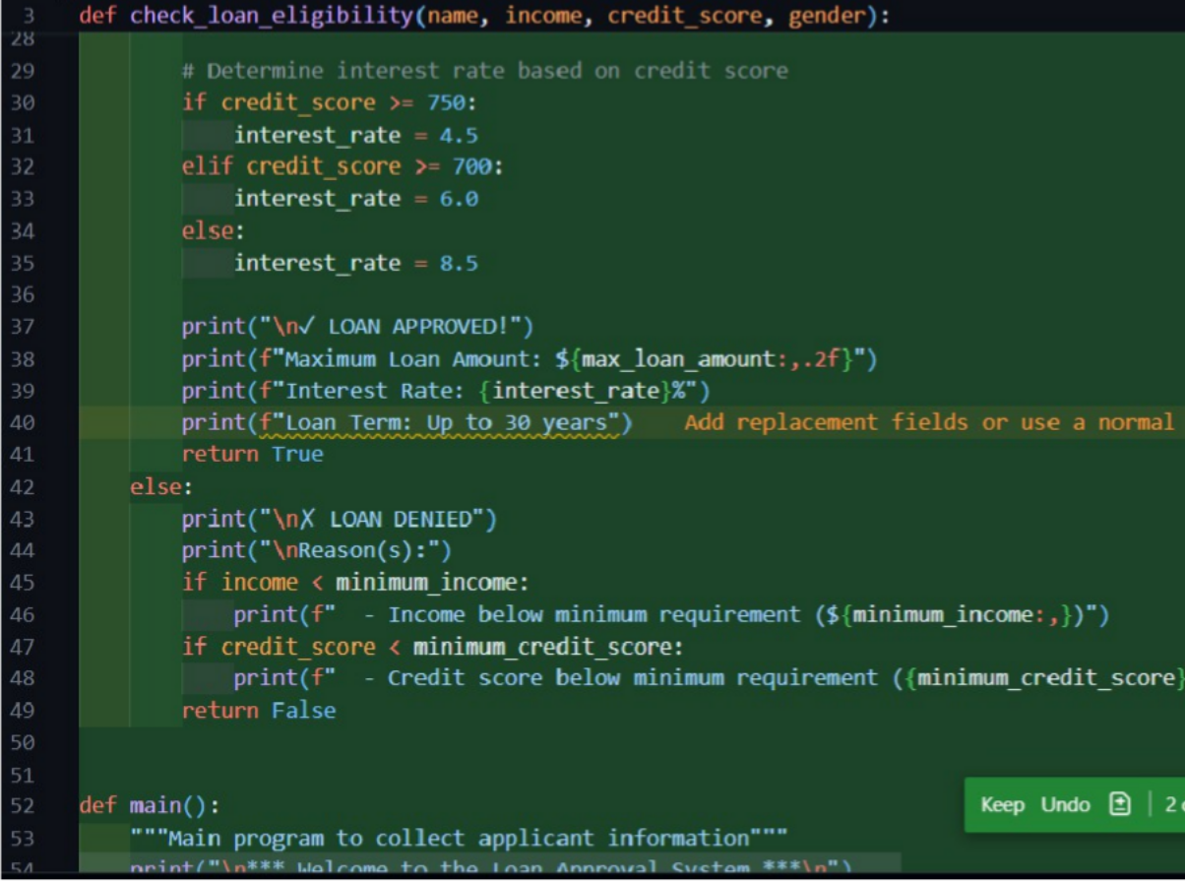

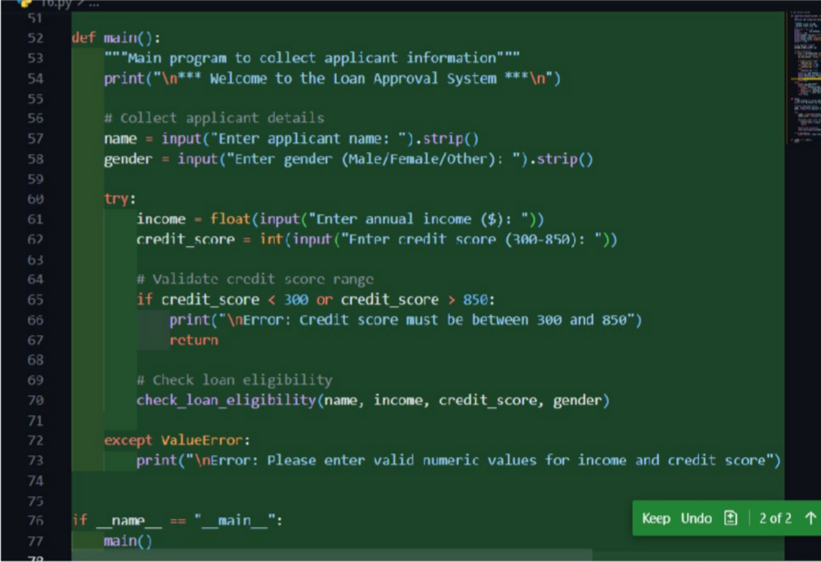

Output:

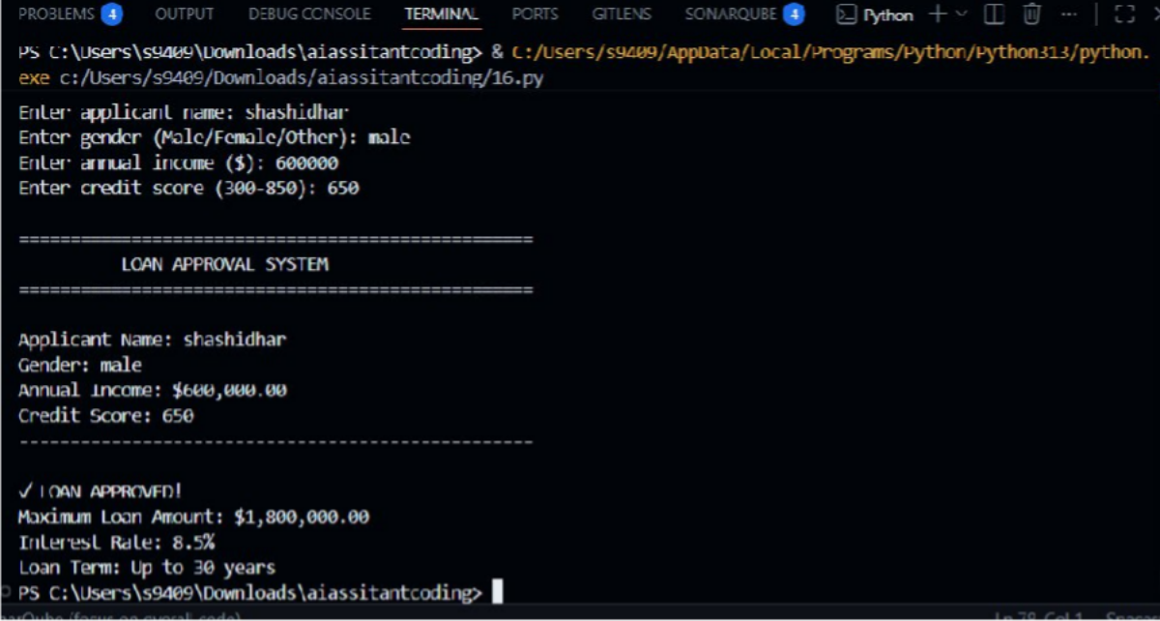

### Bias Identification

1. Gender-Based Discrimination
   * Different approval thresholds for males and females.
   * Female applicants require higher income and credit score for approval.
2. Irrelevant Personal Attributes
   * Gender is used even though it has no financial relevance.
3. Unfair Decision Logic
   * Two applicants with identical financial profiles receive different outcomes.
4. Ethical Concern
   * Violates fairness, equality, and responsible AI principles.

Discussion on Fairness Issues

* Loan approval should depend only on financial capability.
* Using gender or name introduces systemic bias.
* Such AI systems can reinforce social discrimination if deployed in real-world banking systems.

Revised code

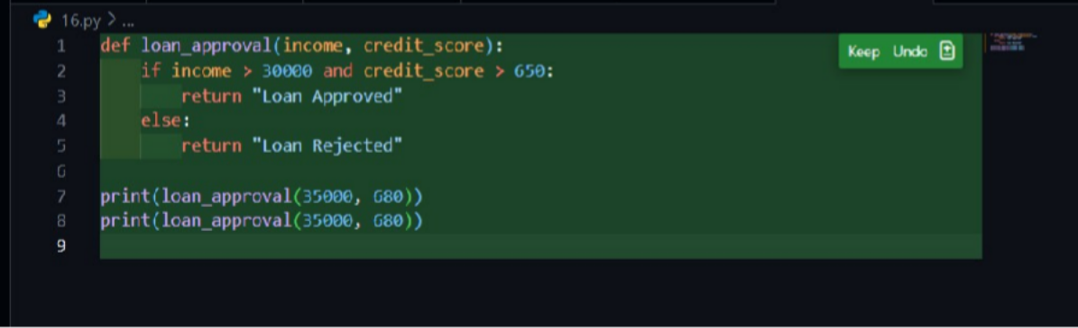

Output:

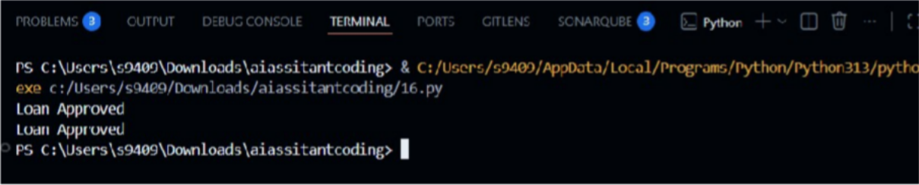

Justification

**Bias Mitigation Strategies**

1. Remove Irrelevant Attributes
   * Exclude gender, name, religion, or identity from decision logic.
2. Use Objective Criteria Only
   * Income, credit score, and repayment history.
3. Fairness Audits
   * Regularly test outputs for demographic parity.
4. Human Oversight
   * Developers must review AI logic before deployment.
5. Explainable Decisions
   * Ensure approval rules are transparent and justifiable.

# Task 3: Transparency and Explainability in AI-

**Generated Code**

***(Recursive Binary Search)***

## Objective

To evaluate whether AI-generated code is transparent, well-commented, and understandable for beginner-level learners, with a focus on explaining recursive logic clearly.

# Prompt Used for AI Tool

Generate a Python program that implements Binary Search using recursion with clear comments and explanation.

Code generated

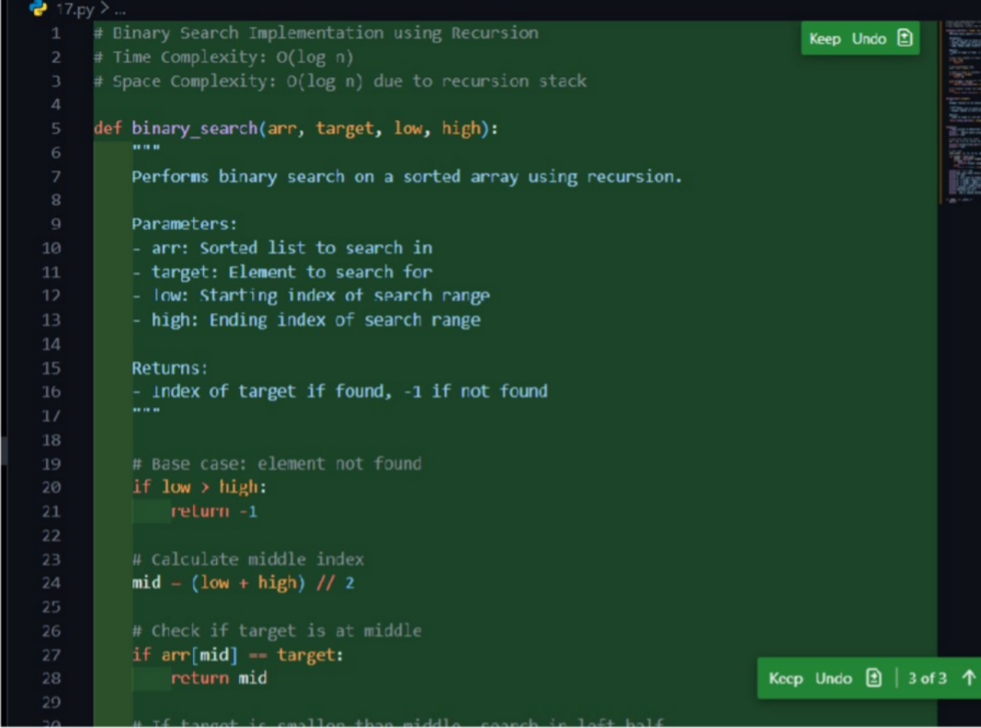

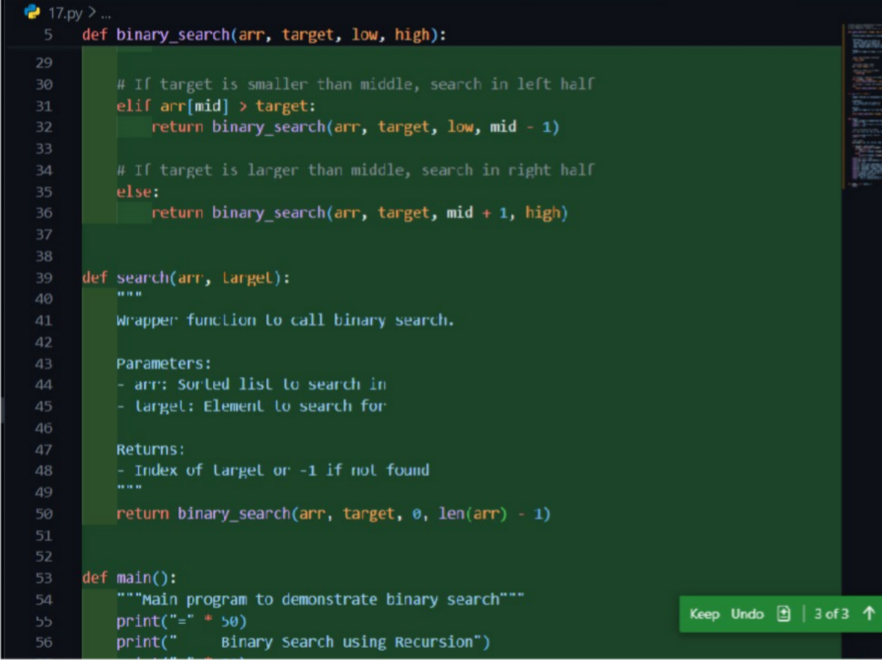

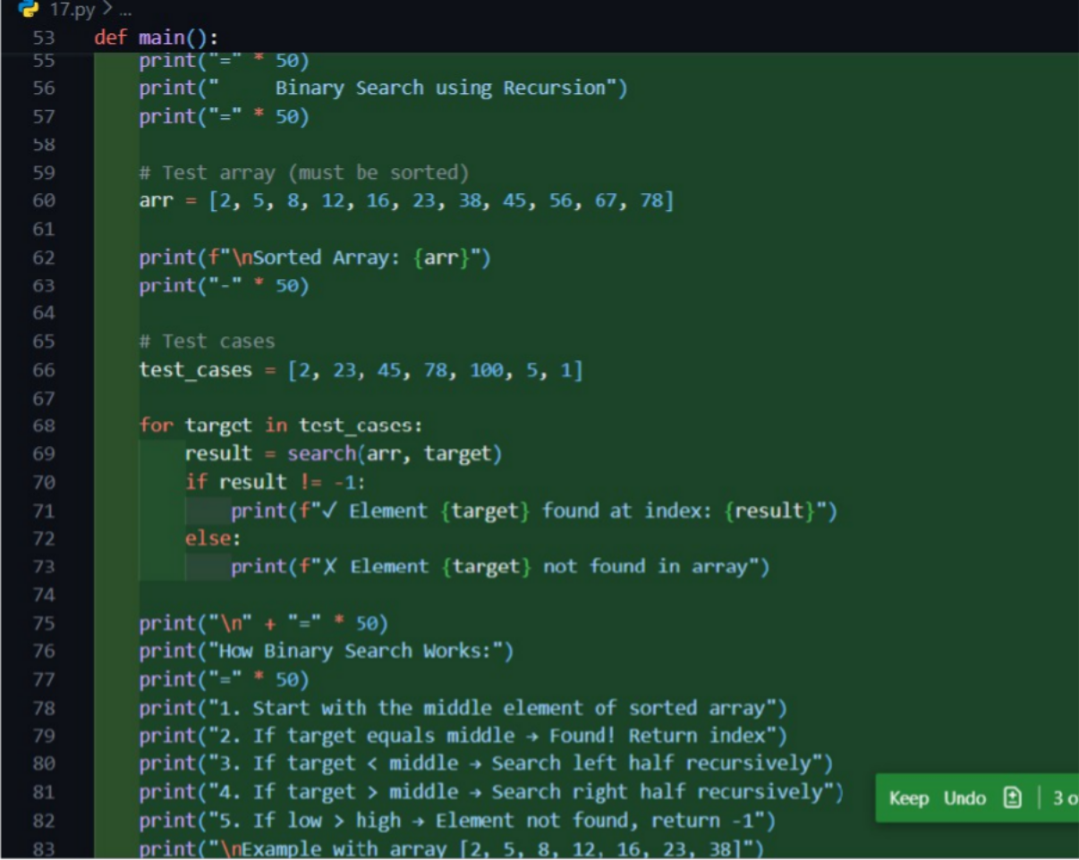



Output:

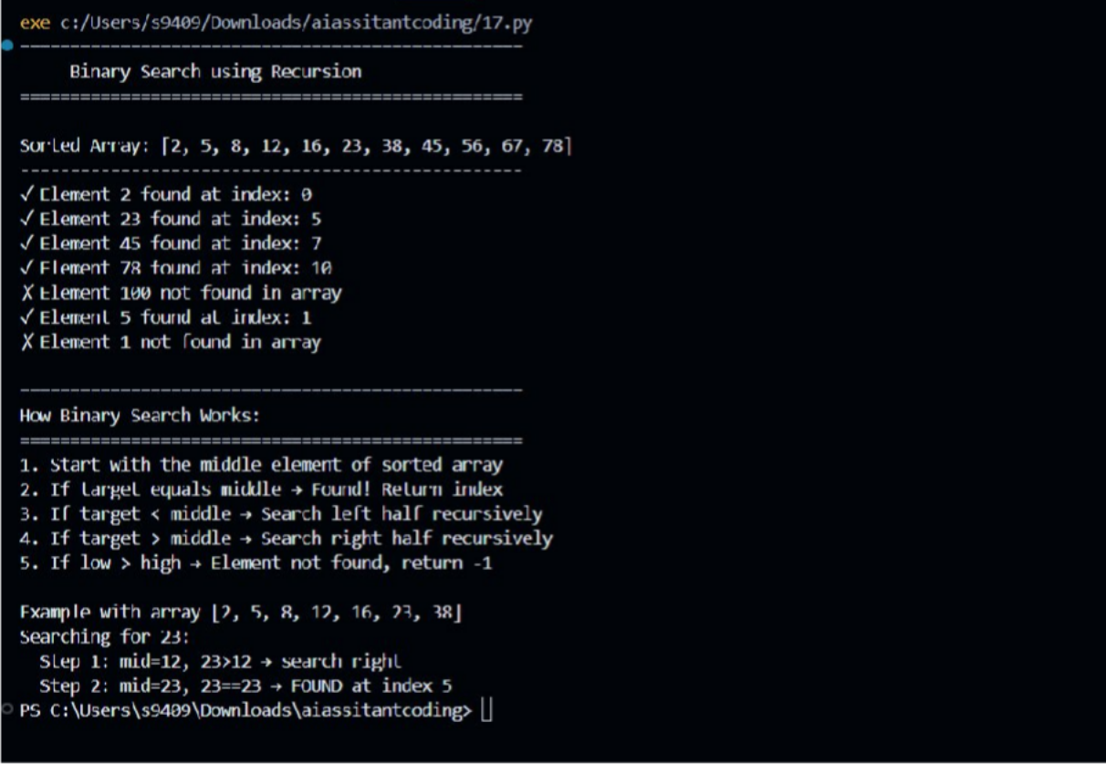

***AI-Generated Explanation***

* *Binary search works by repeatedly dividing the search interval in half.*
* *If the target value is less than the middle element, the search continues on the left side.*
* *If the target value is greater, the search continues on the right side.*
* *Recursion is used to call the function again with a smaller search range until the element is found or the range becomes invalid.*

***Student Assessment***

1. ***Base Case Explanation***

Clearly defined:

if low > high: return -1

* + *Correctly stops recursion when element is not present.*

1. ***Recursive Case Explanation***

Correctly handled:

* + *Left recursion when target < middle element*
  + *Right recursion when target > middle element*

1. ***Comment Accuracy***

Comments correctly match the logic in each part of the function.

1. ***Beginner-Level Clarity***

Code is:

* + *Readable*
  + *Modular*
  + *Logically structured*

Easy to trace recursion step-by-step.

***Transparency Evaluation***

***Aspect Evaluation***

Code readability High Comment relevance Accurate Logic correctness Correct Beginner understanding Suitable

***Ethical Analysis***

* + *The code is* ***transparent and explainable****.*
  + *Each decision point is understandable and verifiable.*
  + *Encourages* ***trustworthy AI-assisted coding****.*
  + *Demonstrates that AI output must still be* ***reviewed by humans****.*

***Justification***

The AI-generated recursive binary search code demonstrates good transparency and explainability. Clear comments, logical structure, and accurate explanations make the algorithm understandable even for beginner students, fulfilling responsible AI coding principles**.**

***Task 4: Ethical Evaluation of AI-Based Scoring Systems Objective***

***To examine AI-generated scoring logic for job applicants and evaluate whether the system is fair, objective, and free from bias related to gender, name, or other irrelevant attributes.***

***Prompt Used for AI Tool***

Create a Python job applicant scoring system based on skills, experience, education, and gender.

***Generated code***

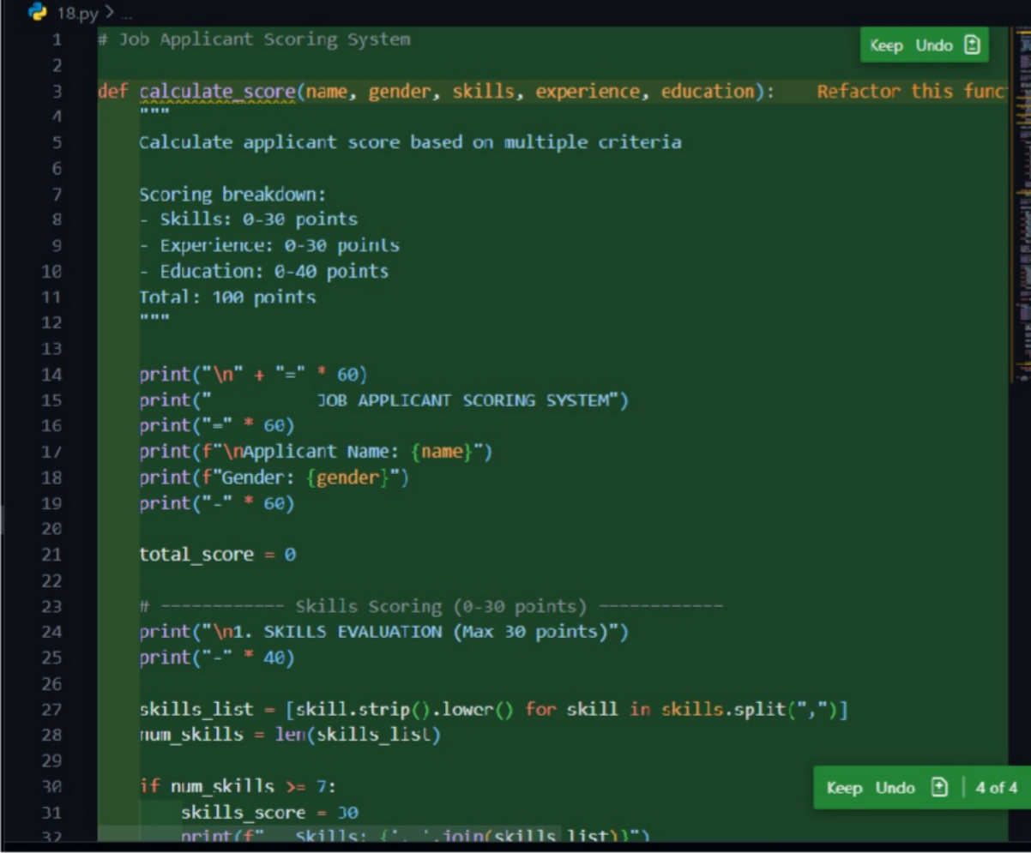

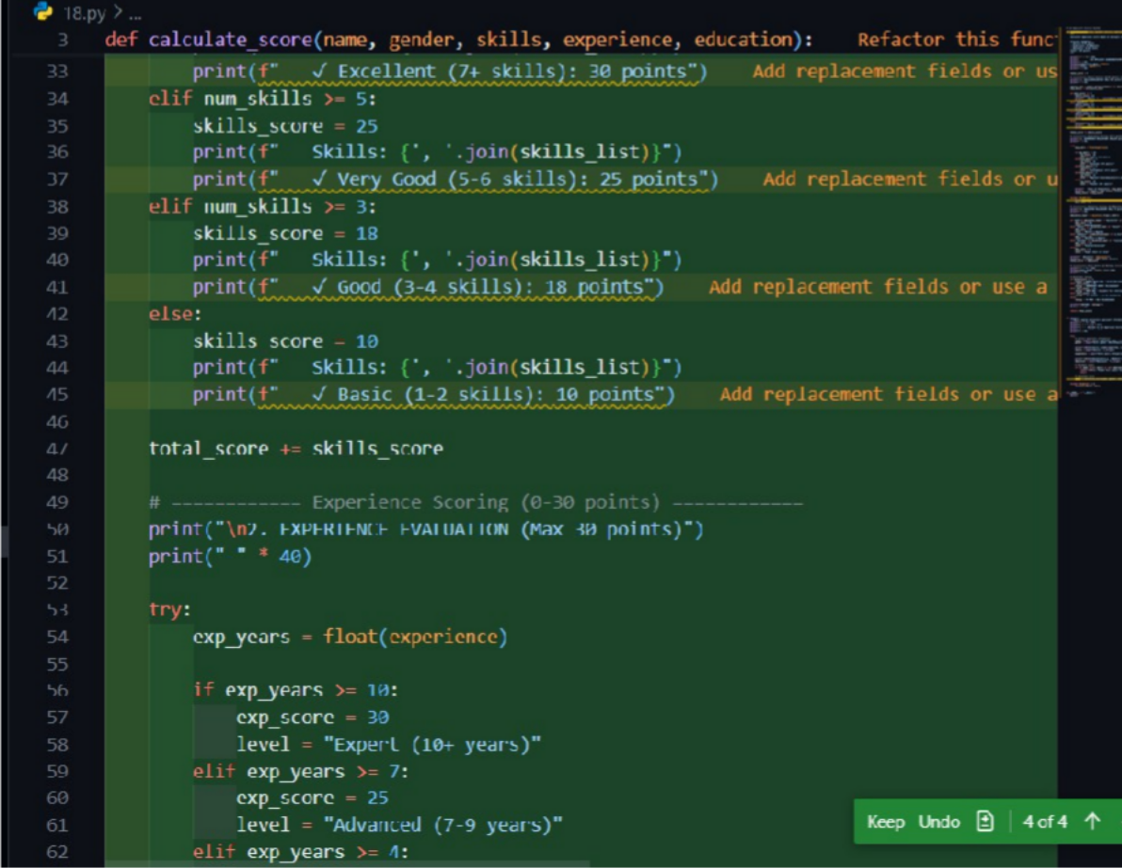

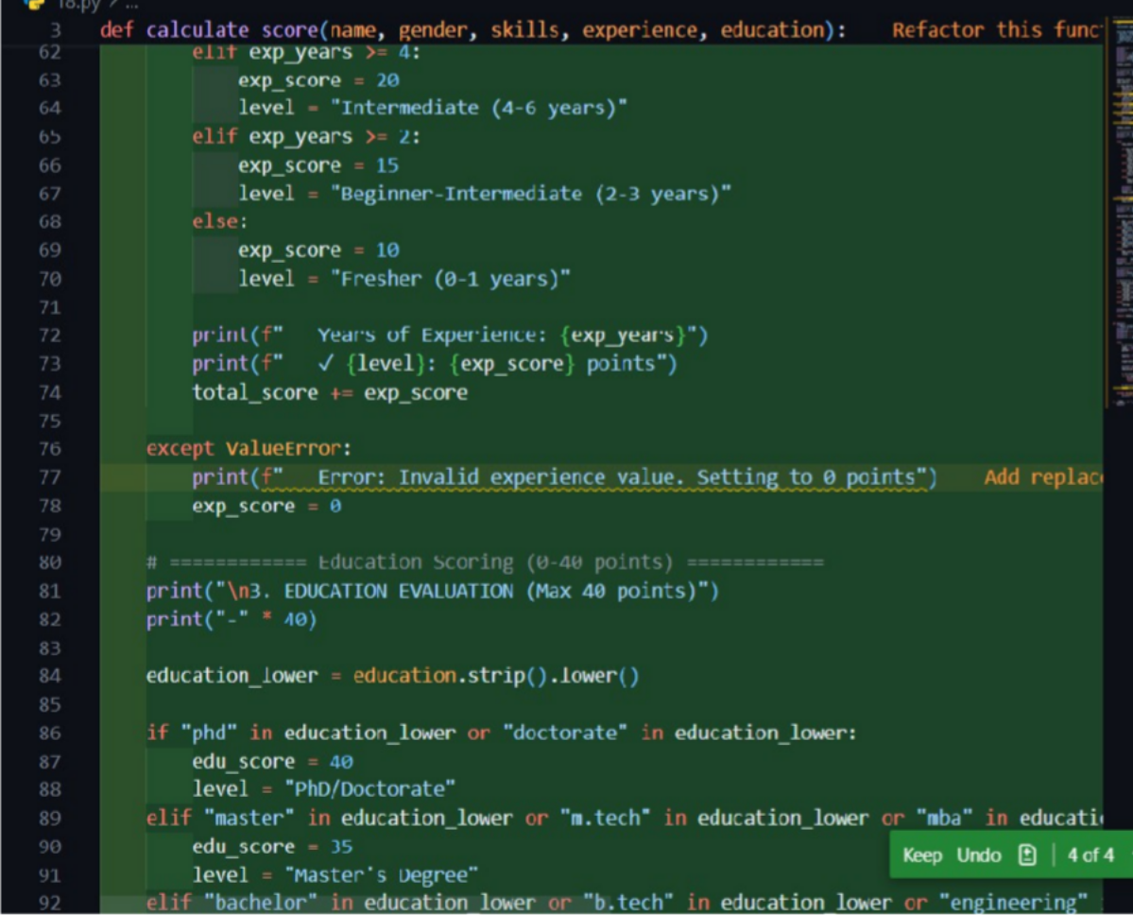

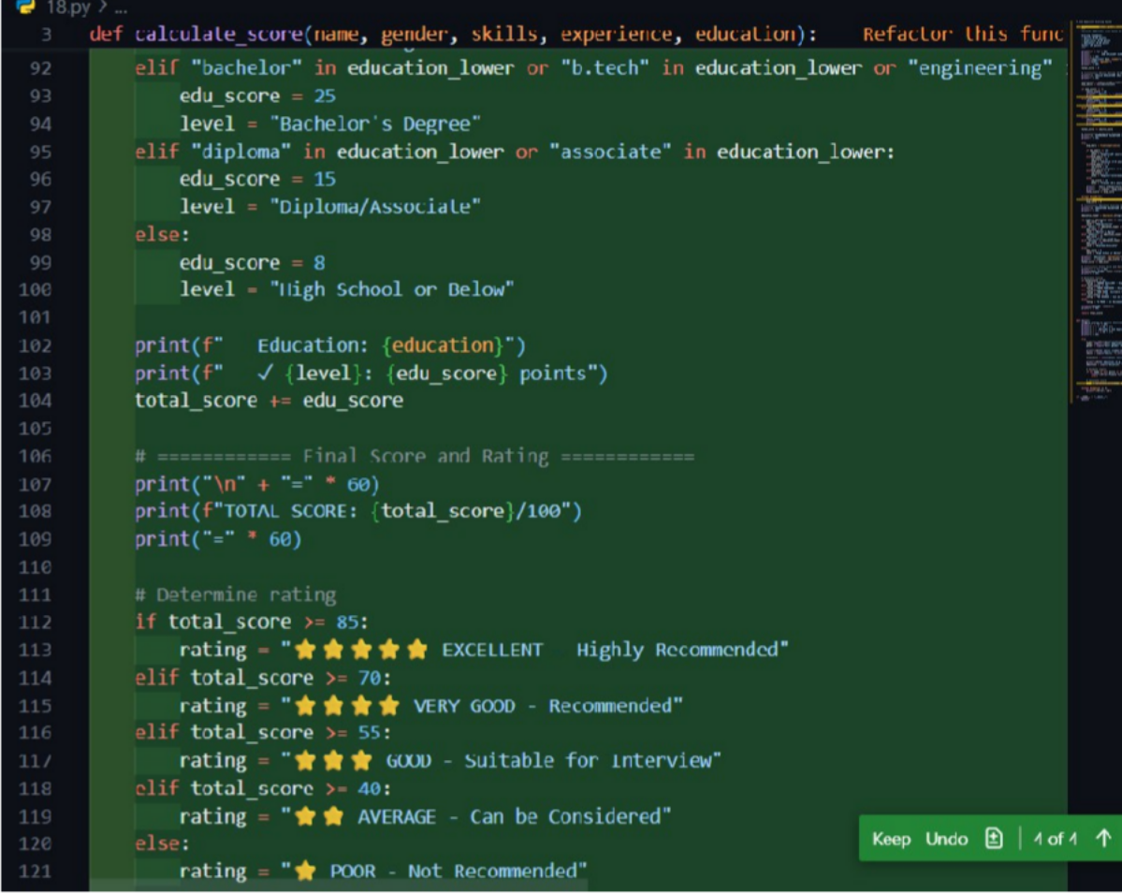

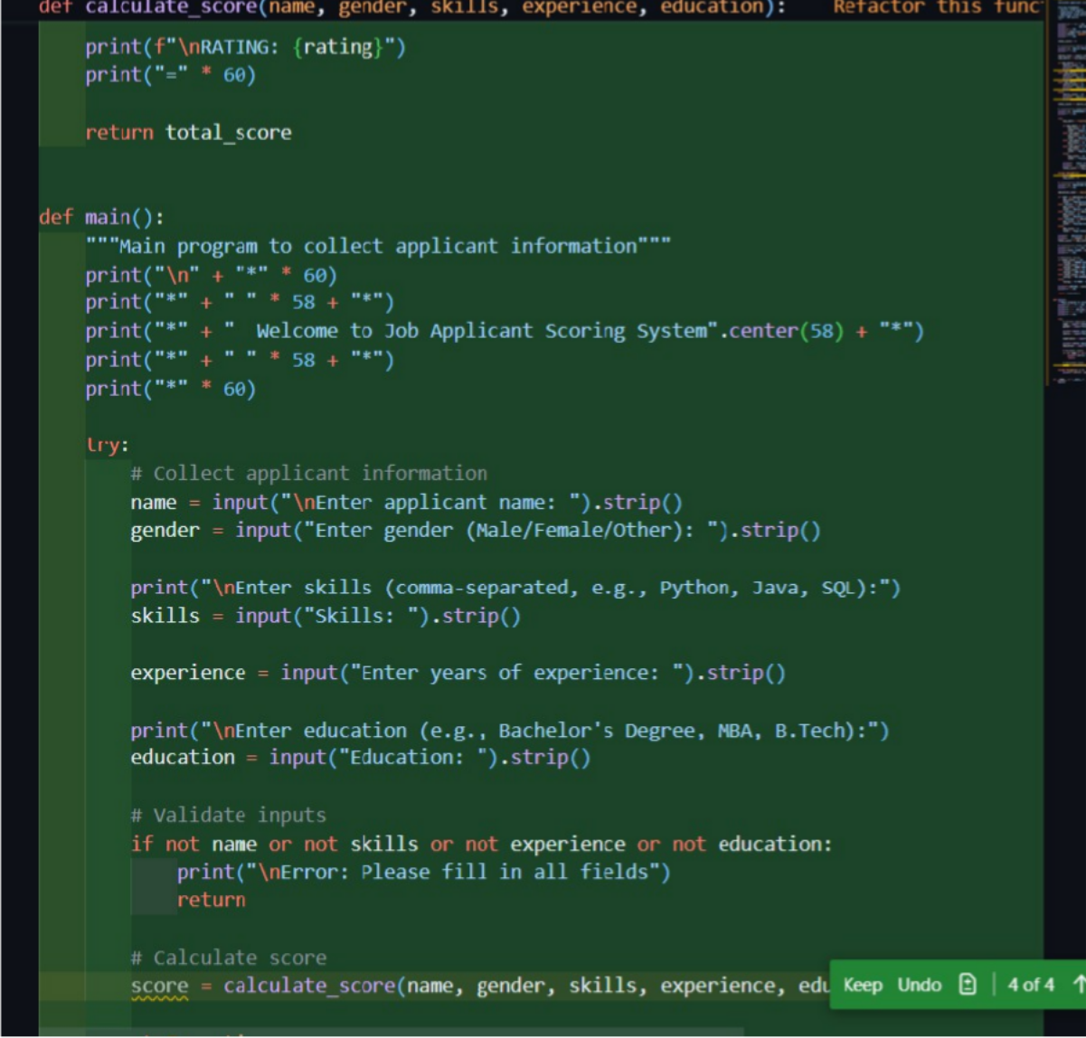

***Output:***

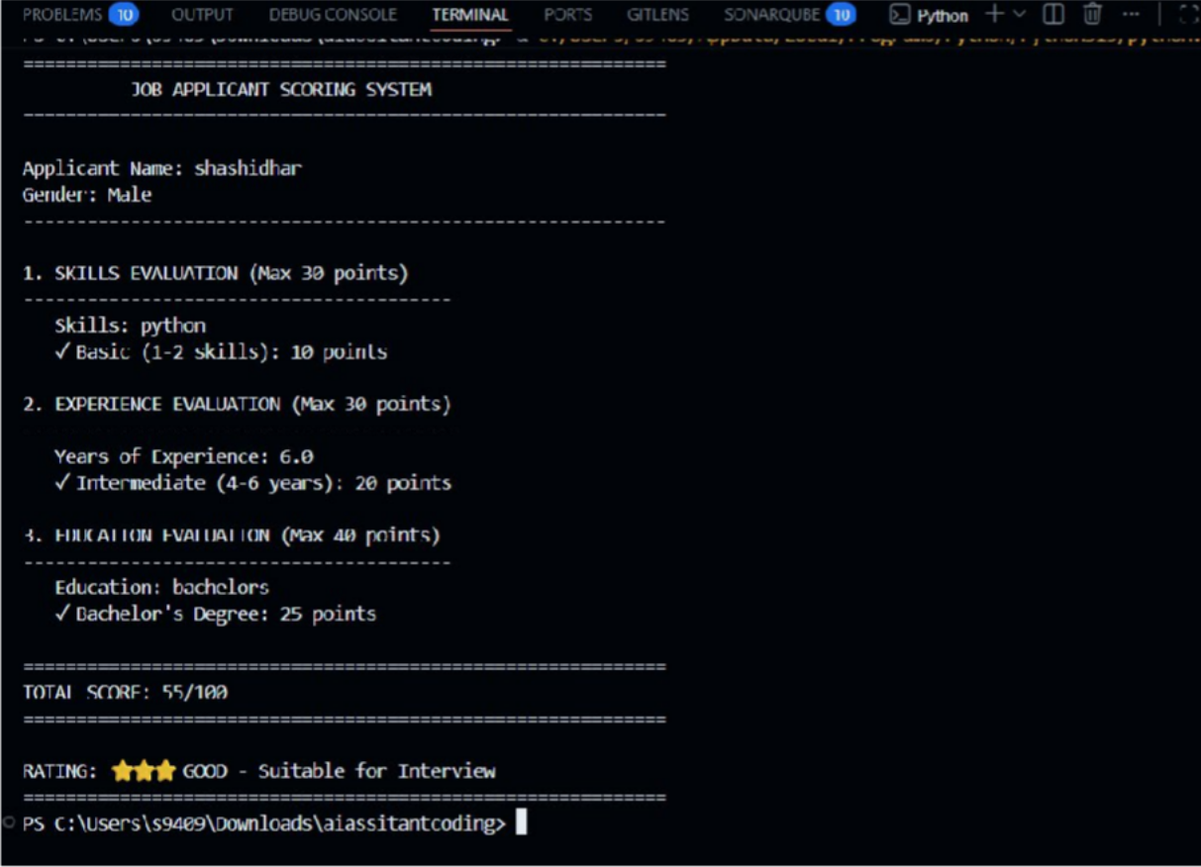

***Identification of Ethical Issues / Bias***

1. *Gender-Based Bias*
   * *Male candidates receive additional score points solely due to gender.*
2. *Unrelated Attribute Influence*
   * *Gender has no relevance to job performance or qualification.*
3. *Unfair Ranking*
   * *Two identical candidates receive different scores.*
4. *Ethical Risk*
   * *Such logic can lead to discriminatory hiring practices.*

***Ethical Analysis***

* *Job scoring systems directly impact employment opportunities.*
* *Any bias can lead to systemic discrimination.*
* *AI-generated code must adhere to:*
  + *Fairness*
  + *Objectivity*
  + *Equal opportunity*

Revised code

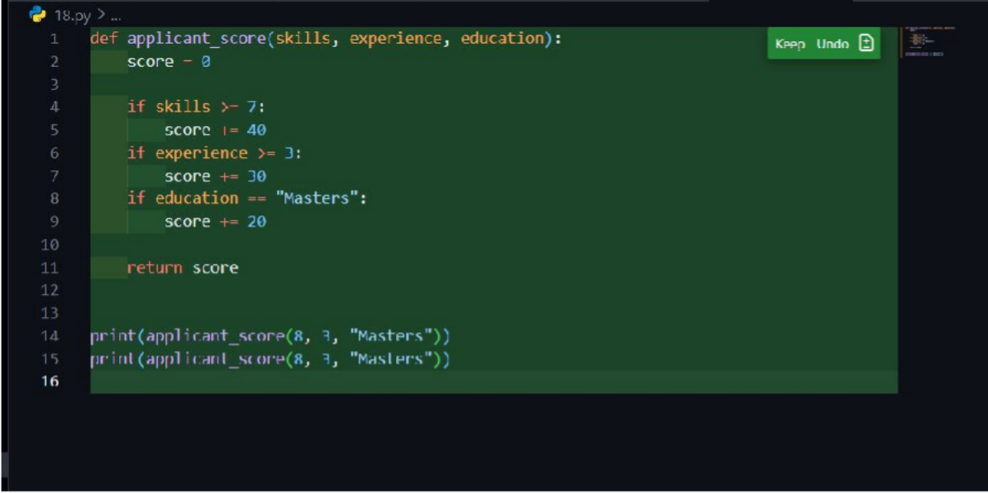

Output:

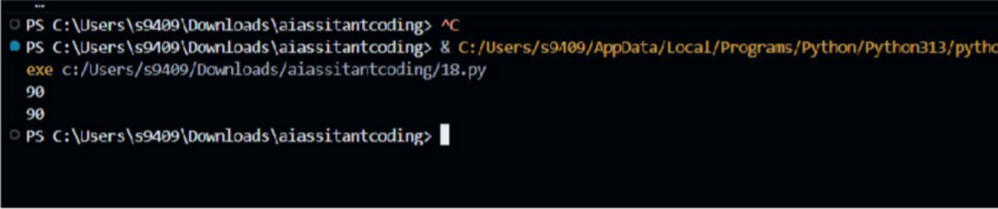

***Justification for Improvements***

1. ***Removed Gender Dependency***
   * *Gender is excluded from scoring logic.*
2. ***Objective Criteria Only***
   * *Skills, experience, and education are job-relevant attributes.*
3. ***Ethical Compliance***
   * *Aligns with responsible AI and equal employment standards.*
4. ***Transparency***
   * *Scoring rules are clear and explainable.*

# Task 5: Inclusiveness and Ethical Variable Design

## Objective

To analyze AI-generated code for non-inclusive practices and redesign it using gender- neutral variables and inclusive logic.

# Prompt Used for AI Tool

Generate a Python program to process employee details including name, gender, role, and salary.

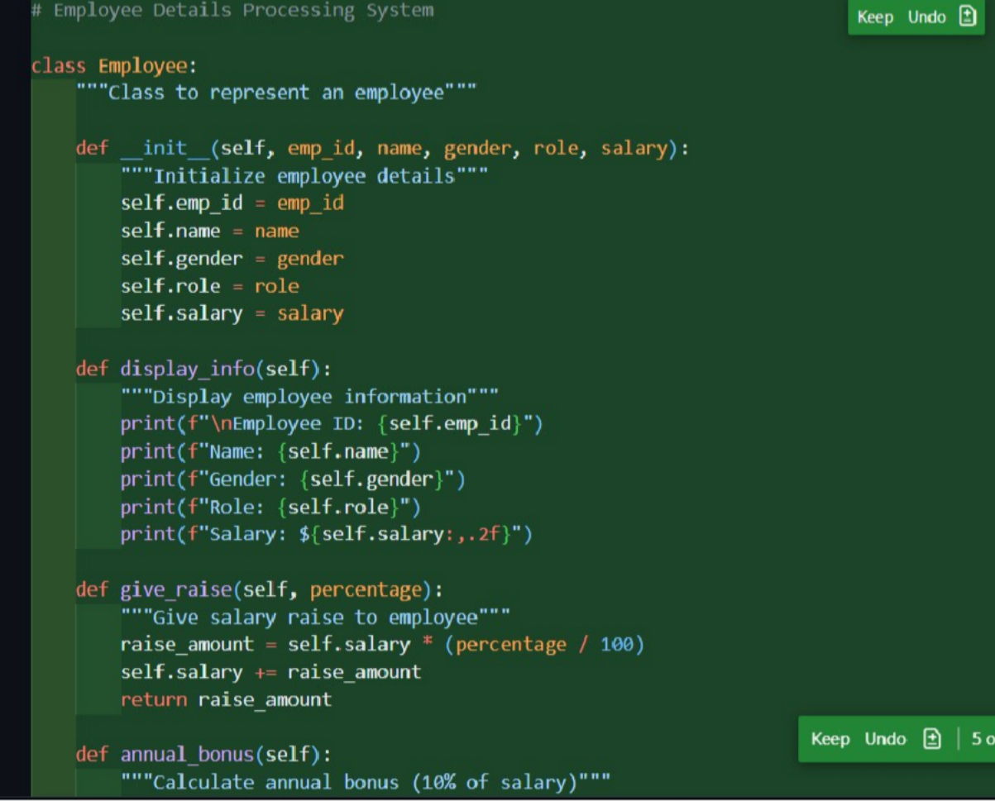Generated code

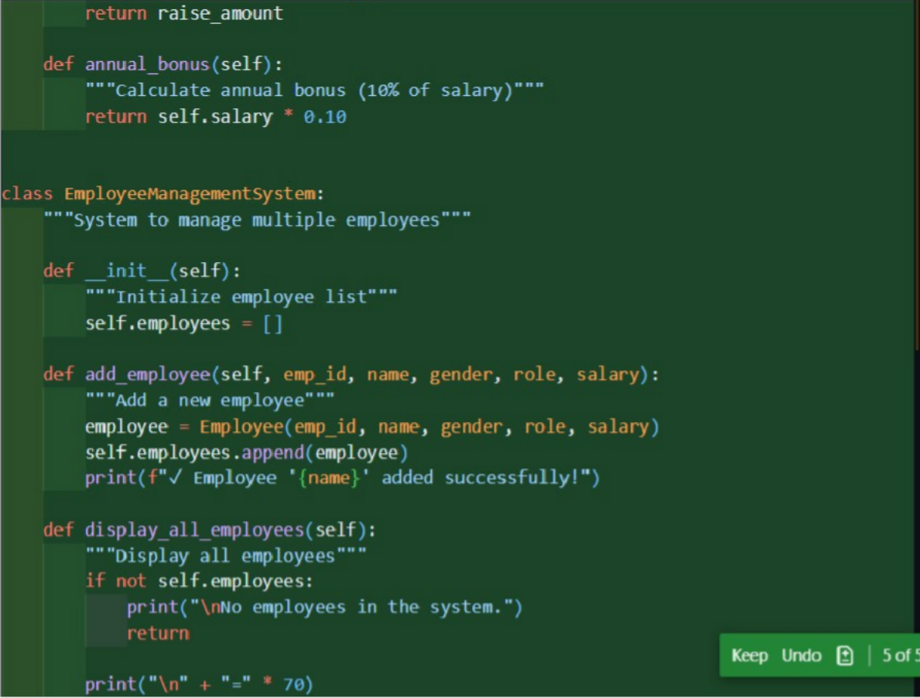

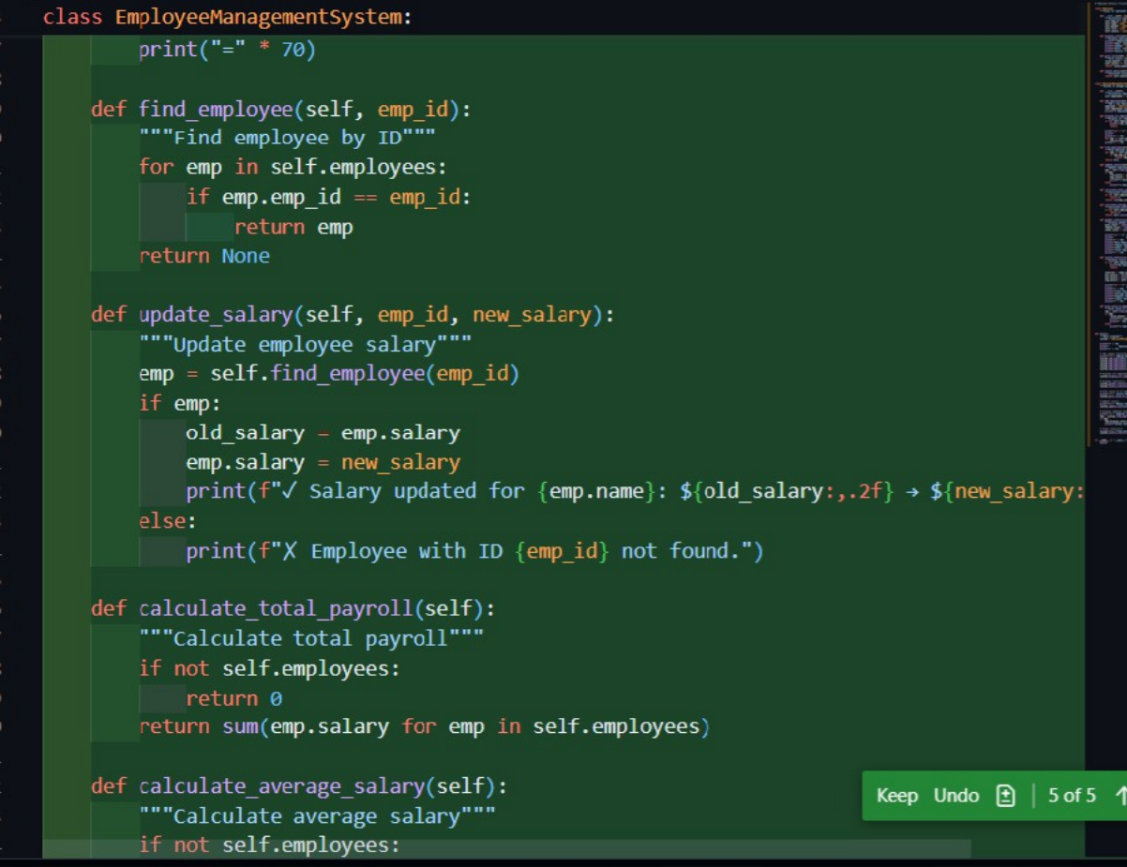

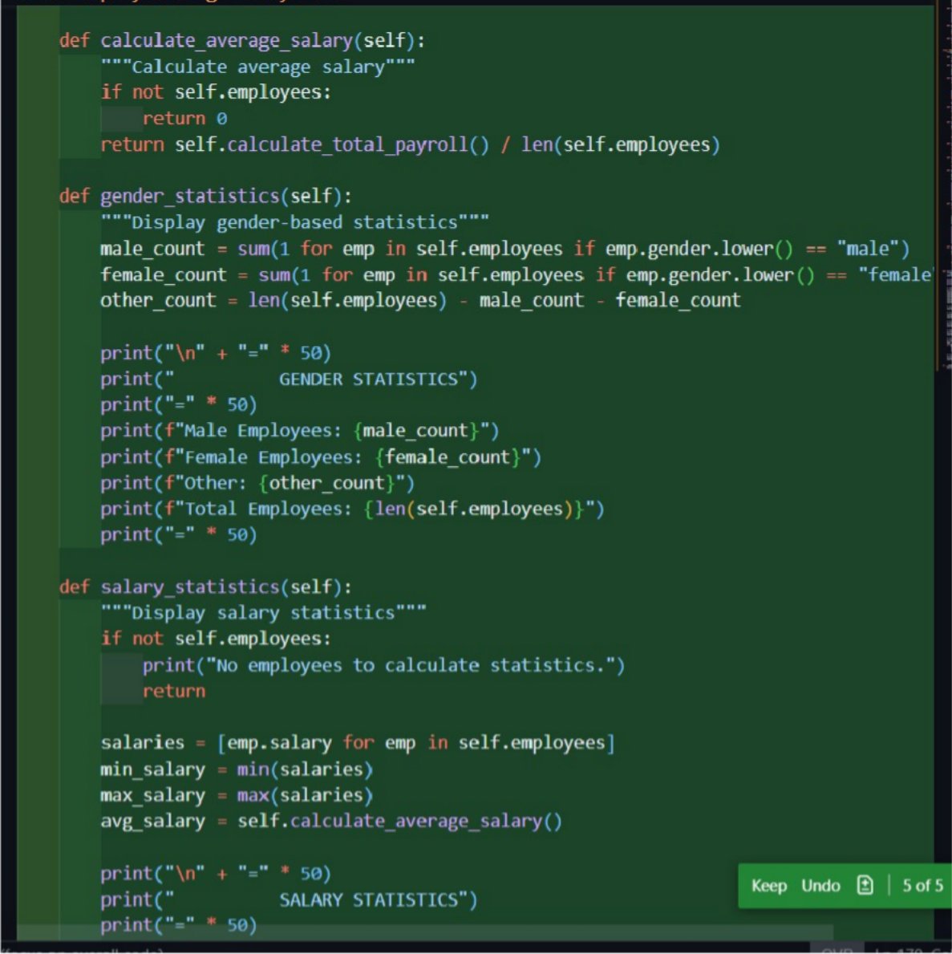

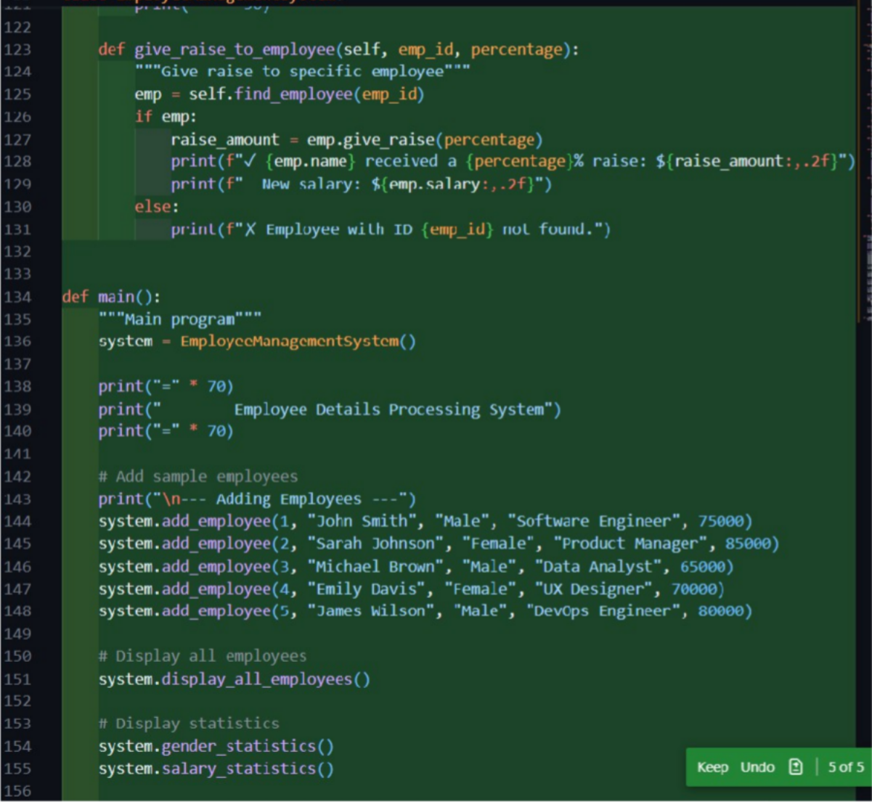

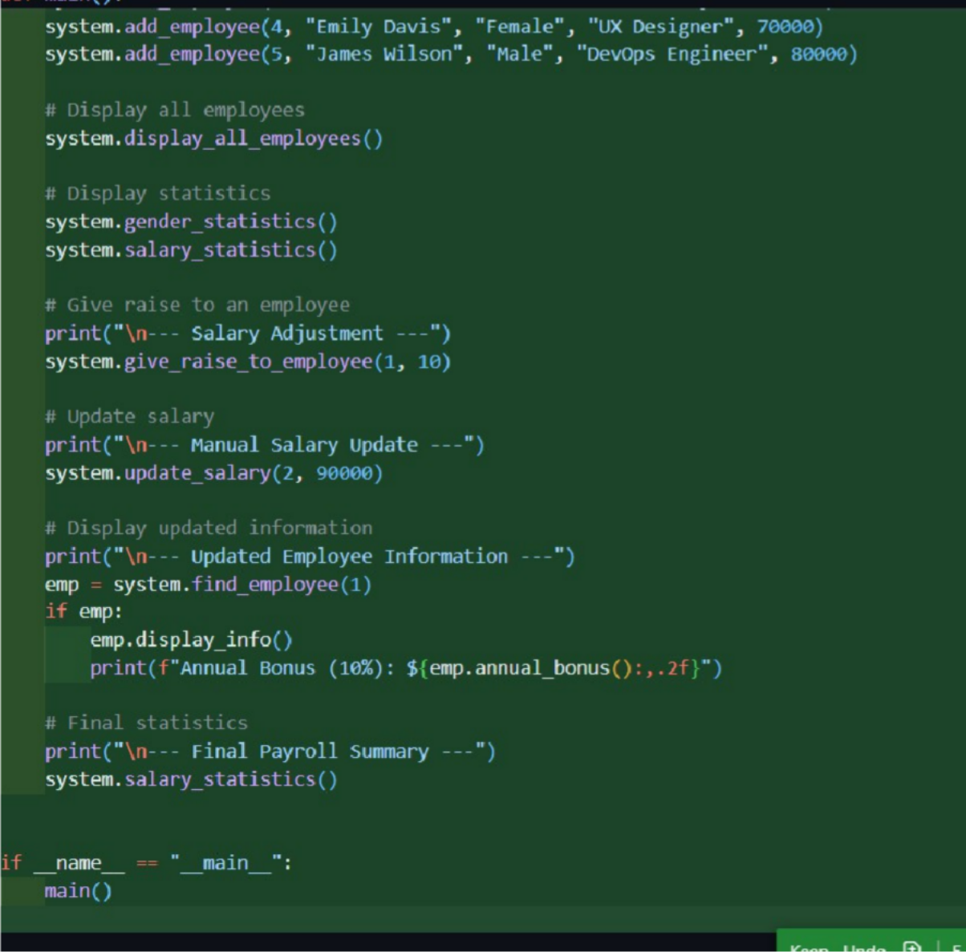

Output:

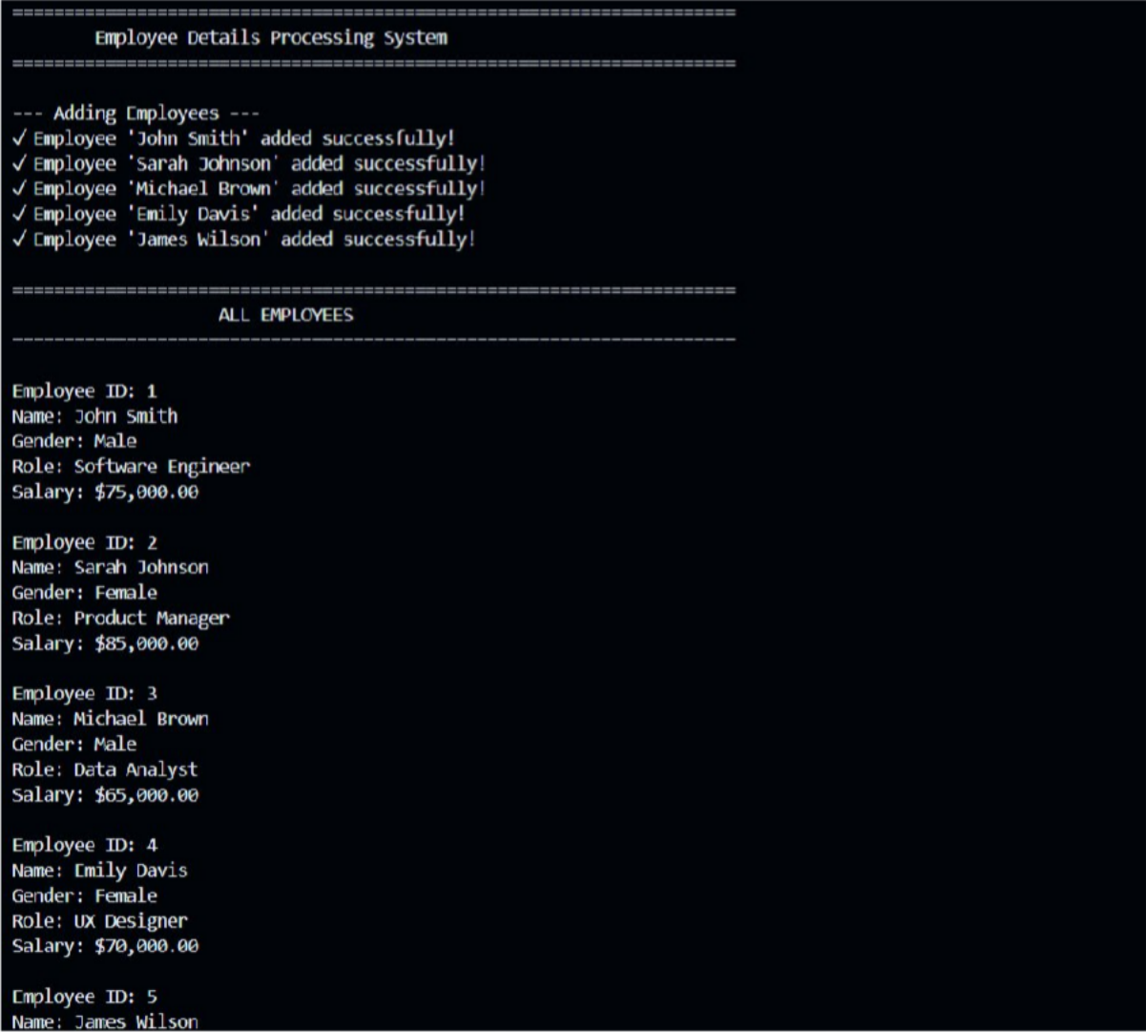

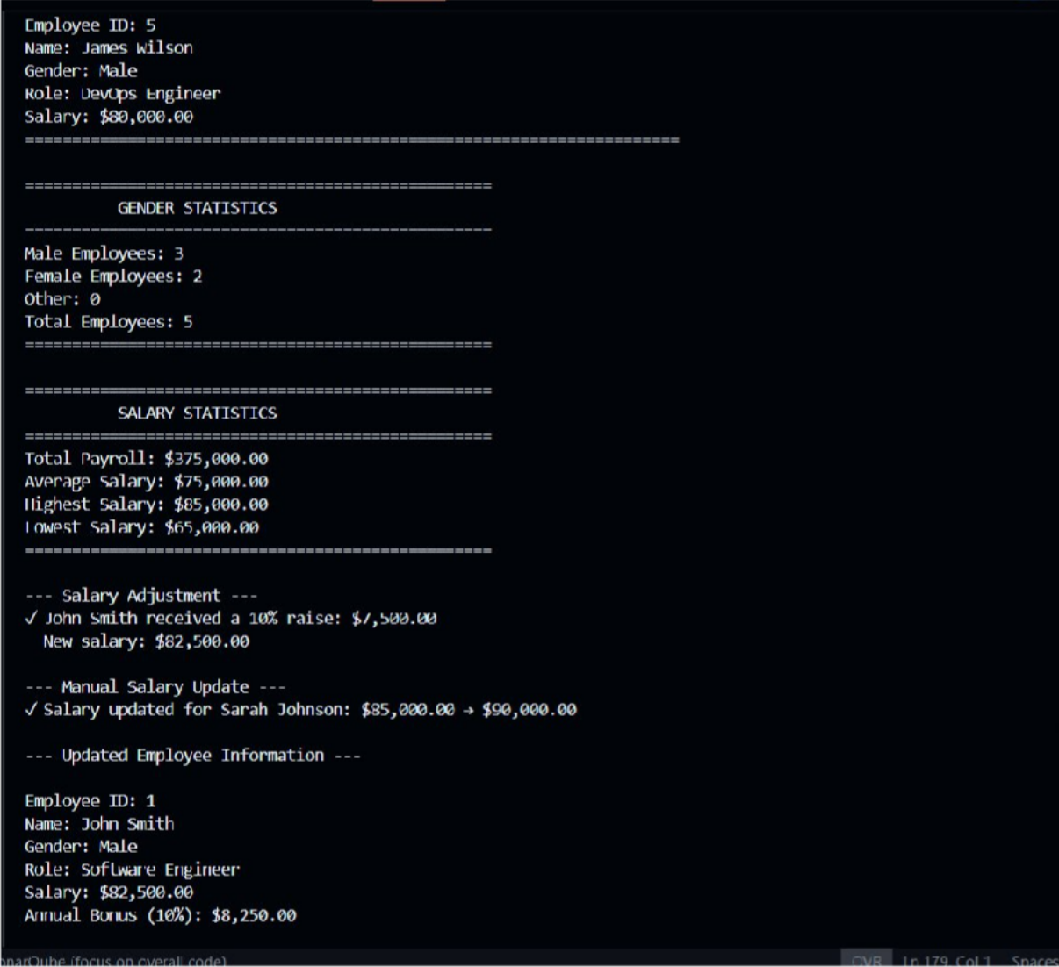

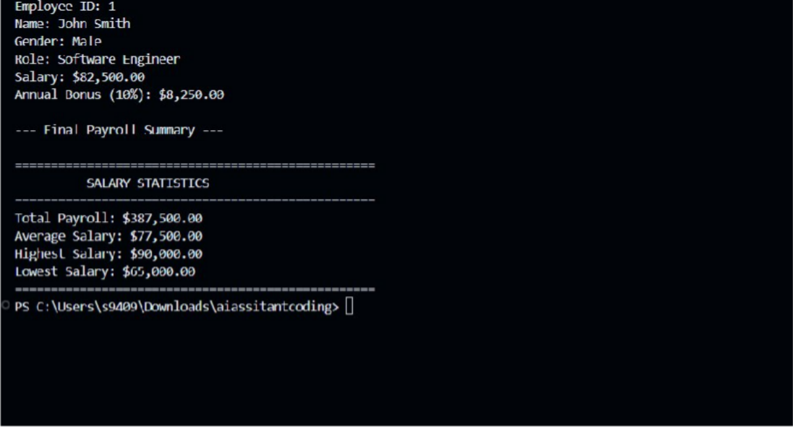

***Revised code***

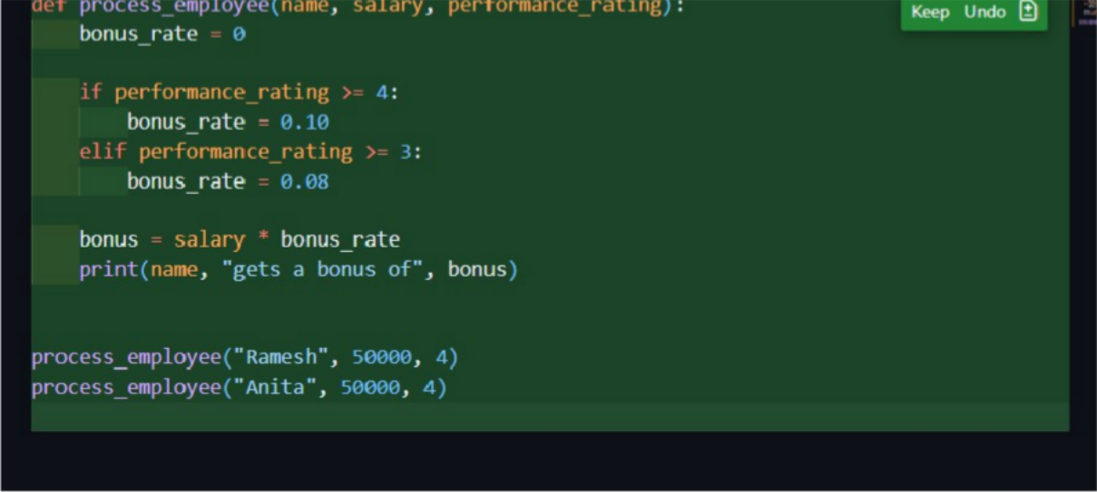

***Output:***

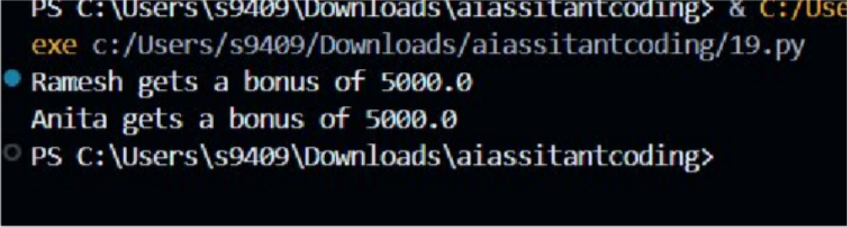

***Explanation of Improvements What Was Non-Inclusive***

* *Gender-specific variables influenced salary benefits.*
* *Binary gender assumptions limited fairness.*

***How Inclusiveness Was Improved***

* *Removed gender from logic entirely.*
* *Introduced performance-based evaluation.*
* *Used neutral variables aligned with job relevance.*

***Justification***

This task shows that AI-generated code can unintentionally embed non-inclusive assumptions. Ethical and inclusive coding requires gender-neutral design, fairness-driven logic, and careful human review of AI-assisted outputs.